SoccerAPP : This is the main entry point for the application. This class present main GUI and spawn child classes based on user action. In the constructor, It will Initialize the UDT Handler class(which is responsible for storing data in UDT) and Wasp3D shotbox SDK, for loading and controlling the graphics in sting server.
During start up it will fetch the udt and get load the data into GUI. Last selected details are automatically get selected including last active match, last active match part. Once the application is loaded the GUI will appear as below

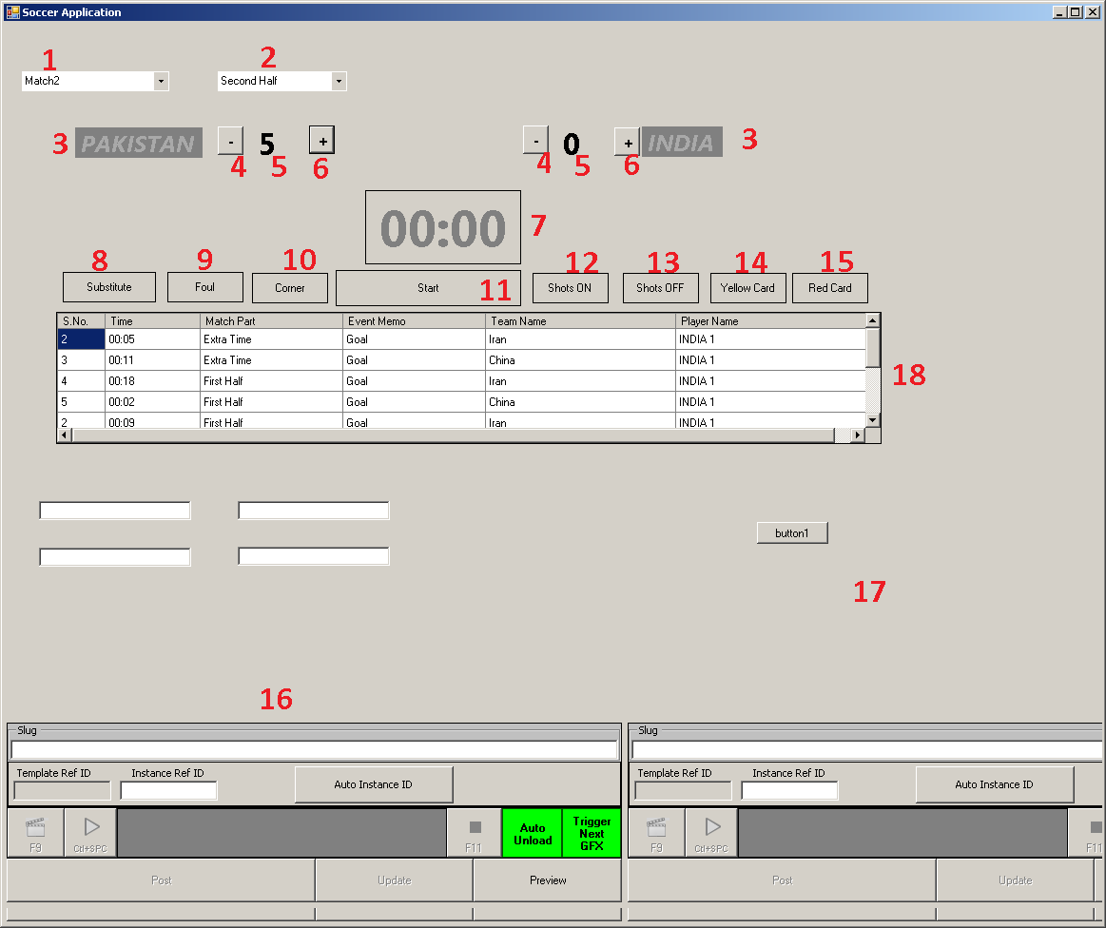
Below are the functionality of the application

Point 1 Match List: Lists all matches in UDT. Matches are created inside UDT. On changing the match points 2,3,5,7 and 18 are get effected. The information related these points are retrieved from UDT on selection change event of Match Combo. The counter(point 7) will also reset to zero on match change
Point2 Match part: Lists match parts like first half, second half, extra time etc.. on changing this value will effect point 7 which will be reset to zero.
Point 3 Team Name: Depending upon the match selected the team name would be displayed . The left side will display the home team and right side will display Away team. A flag of the team would also will be displayed along with the team name. On double clicking on the team name , squad building form would be displayed. The data is retrieved from UDT and filled in the list of squad selection window.

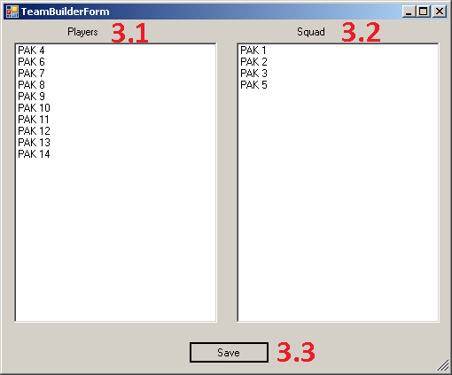

Point 3.1 Team : This list box would display all the team members in the team. Players information is added into the UDT directly. User can directly drag items from players list box to 3.2 making that particular player in the squad.
Point 3.2 Squad: This list box displays the current squad available in UDT. User can remove any player from squad by dragging that player and dropping in 31.
Point 3.3 Save: On clicking Save the current squad and players information is updated in UDT
Point 4 Score correction: In case there is a need to correct the score, clicking on this button would decrease the score by one at point 5 and update the udt accordingly. Since the score bug scene will also get effected by this action, it would send the update and play related animation using Shot box SDK.
Point 5 Score: Score for the corresponding teams. Initially the score would be displayed from UDT. The figure would be get updated through point 4 and point 6.
Point 6 Score Increment: Increment the score by 1. point 5 would be effected by this action. The button click event will update the team score in UDT. This action will also add an entry to point 18 and also insert a row in Match event table in UDT
Point 7 Timer: This will display the count down timer. Value will get updated in every 1 second. The initial value for count down is set to 45 minutes automatically except in the case of match part chosen is extra time. In this case this control would accept user input value.
Point 8 Substitution: When ever a substitution event occurs, user can click on the control. On click event a new form is open filled with team names and their player. These information is updated in UDT and a new row is added to Match event table in UDT. The following window is opened on clicking the button
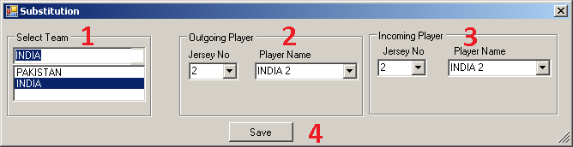

Point 8.1 Team selection: selecting the team on which the substitution event is happening. On selection change of the team combo, player information is filled in 8.2 and 8.3 .
Point 8.2 Outgoing Player: Displays the out going player information. One can select the player either using jersey number or by name. Choosing any one of them will automatically choose the other.
Point 8.3 Incoming Player: Selection of incoming player. All other functionality is same as 8.2
Point 8.4 Saving the data: On click of the button, the selected information is saved into UDT
Point 9 Foul selection: on click of the button, foul selection window is opened. This information is then inserted into match event table of UDT. The following window will open on selection
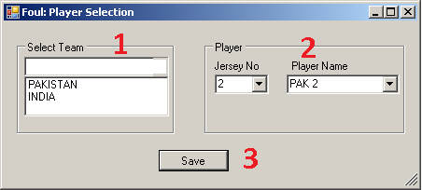

Point 9.1 Team selection: Select the team and accordingly the player information would be filled in 9.2 .
Point 9.2 Player Selection: Select the player who made foul. User can select the player either by choosing the jersey no or by selecting the Name
Point 9.3 Saving the data: On save button click the selected information would be inserted into match event table in UDT. This information would also added into teams statistics
Point 10 Corners: clicking on corner button would invoke team selection window. This information would be added into the team statistics and also inserted into match events. The below window will pop up when user click on corner button
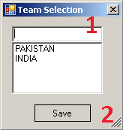

Point 10.1 Team selection: select the team who made the corner. User can either select the team and then press the save button or double click on the team to close this window and save information into UDT
Point 10.2 Saving the information: saves the information into UDT
Point 11 Start/Stop the counter: Clicking on the button would start the count down by starting the timer. It will also trigger the graphic loaded on sting server using shotbox SDK. The timer on the scene would run independently of the counter on the form. By clicking the Stop button the counter on the form stop displaying data, but actual timer would be running. This is because in soccer once the timer started, it will not stop.
Point 12 Shots On: Whenever shots on target happens, user can select the team and player and add that information to team statistics and into match statistics. Clicking on shots on goal would open up the player selection window as below

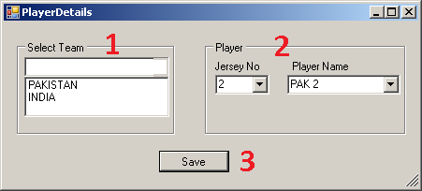

Point 12.1 Team selection: Select the team and accordingly the player information would be filled in 12.2 .
Point 12.2 Player Selection: Select the player who made Shots. User can select the player either by choosing the jersey no or by selecting the Name
Point 12.3 Saving the data: On save button click the selected information would be inserted into match event table in UDT. This information would also added into teams statistics

Point 13 Shots OFF: Whenever shots off target happens, user can select the team and player and add that information to team statistics and into match statistics. Clicking on shots on goal would open up the player selection window as below

Point 13.1 Team selection: Select the team and accordingly the player information would be filled in 13.2 .
Point 13.2 Player Selection: Select the player who made Shots. User can select the player either by choosing the jersey no or by selecting the Name
Point 13.3 Saving the data: On save button click the selected information would be inserted into match event table in UDT. This information would also added into teams statistics
Point 14 Yellow Card : When ever a player receives yellow card, user can click on this button and then choose the team their player who received the yellow card. The selected information would be added into team statistics, player statistics and also into match events in UDT. Clicking on the button will open the player selection window as below

Point 14.1 Team selection: Select the team and accordingly the player information would be filled in 14.2 .
Point 14.2 Player Selection: Select the player who received yellow card. User can select the player either by choosing the jersey no or by selecting the Name
Point 13.3 Saving the data: On save button click the selected information would be inserted into match event table in UDT. This information would also added into teams statistics
Point 15 RED Card : When ever a player receives Red card, user can click on this button and then choose the team their player who received the red card. The selected information would be added into team statistics, player statistics and also into match events in UDT. Clicking on the button will open the player selection window as below

Point 14.1 Team selection: Select the team and accordingly the player information would be filled in 14.2 .
Point 14.2 Player Selection: Select the player who received red card. User can select the player either by choosing the jersey no or by selecting the Name
Point 13.3 Saving the data: On save button click the selected information would be inserted into match event table in UDT. This information would also added into teams statistics

